Derivadas parciales, integrales múltiples y operador de Laplace

Derivadas parciales de primer orden
http://en.wikibooks.org/wiki/Calculus/Partial_differential_equations
Any partial differential equation of the form
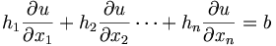
where h₁, h₂ … h_{n}, and b are all functions of both u and R^{n} can be reduced to a set of ordinary differential equations.

Derivación de funciones implícitas
(Granville, Cálculo, Art. 231, p. 560.)
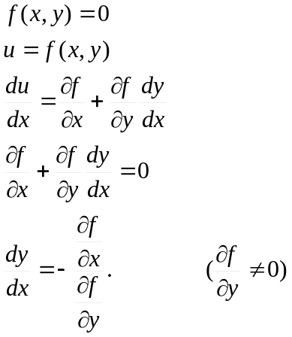
Ejemplo 1 (Art. 231, p. 561.):
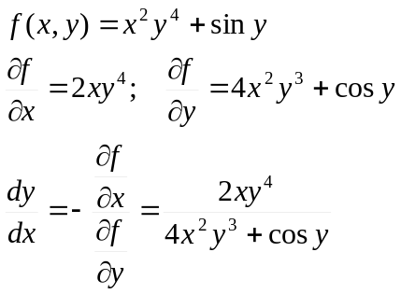
Ejemplo 2 (aplicado al Art. 41, p. 50.):
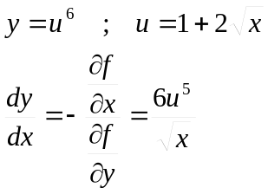

Integrales de superficie
De http://eom.springer.de/S/s091350.htm:
An integral over a surface. Let a surface in the three-dimensional Euclidean space , possibly with self-intersections, be specified by the vector representation
(1)
in Cartesian coordinates , where is a continuously-differentiable vector function defined on the closure of a two-dimensional Jordan-measurable domain lying in the plane with Cartesian coordinates and . Let
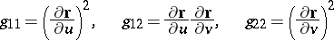
be the coefficients of the first fundamental form of . If is a function defined on , i.e. a function , then the following defines the surface integral of the first kind (or the integral over the surface area):
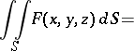 | (2)

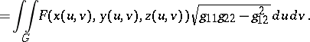
This definition is independent of the representation of the surface.
De Wikipedia (http://en.wikipedia.org/wiki/Surface_integral):
To find an explicit formula for the surface integral, we need to parametrize S by considering on S a system of curvilinear coordinates, like the latitude and longitude on a sphere. Let such a parametrization be x(s, t), where (s, t) varies in some region T in the plane. Then, the surface integral is given by
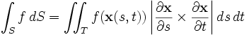

El operador de Laplace
De Wikipedia (http://en.wikipedia.org/wiki/Laplace_operator):
The Laplace operator is a second order differential operator in the n-dimensional Euclidean space, defined as the divergence of the gradient:
Equivalently, the Laplacian is the sum of all the unmixed second partial derivatives:
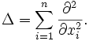
Here, it is understood that the x_{i} are Cartesian coordinates on the space; the equation takes a different form in spherical coordinates and cylindrical coordinates, as shown below.
In the three-dimensional space the Laplacian is commonly written as
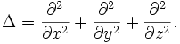
As we shall see later, the Laplacian can be generalized to non-Euclidean spaces, where it may be elliptic or hyperbolic. For example, in the Minkowski space the Laplacian becomes the d'Alembert operator or d'Alembertian
